Introduction: 1

Spec: 1

Design: hardware/software 2

Raspberry Pi emulator 2

Raspberry Pi over the years 3

Flow chart 5

Build: hardware/software 5

Test: emulator/hardware 8

Conclusion: individual section 9

Alan: 9

Taha: 9

# Introduction:

We are looking at the Raspberry pi 4 in this document, Pi 400 is the newest version of the pi and has so much more to offer anyone who buys one, they are capable of running many OS (Operating Systems),

Since it was released in 2012 the raspberry pi has become more and more popular with in Schools and some third world countries its price and size may be the reason for this.

Below you will see more information on the hardware and software, spec’s and more.

# Spec:

The Raspberry pi 4 has the following specs:

* SoC: Broadcom BCM2711B0 quad-core A72 (ARMv8-A) 64-bit @ 1.5GHz
* GPU: Broadcom Video Core VI
* Networking: 2.4 GHz and 5 GHz 802.11b/g/n/ac wireless LAN
* RAM: 1GB, 2GB, or 4GB LPDDR4 SDRAM
* Bluetooth: Bluetooth 5.0, Bluetooth Low Energy (BLE)
* GPIO: 40-pin GPIO header, populated
* Storage: microSD
* Ports: 2 × micro-HDMI 2.0, 3.5 mm analogue audio-video jack, 2 × USB 2.0, 2 × USB 3.0, Gigabit Ethernet, Camera Serial Interface (CSI), Display Serial Interface (DSI)
* Dimensions: 88 mm × 58 mm × 19.5 mm, 46 g

# Design: hardware/software

Here we see the CPU BCM2711Bo which is more powerful than the other raspberry pi’s, offering more smooth and better performance than any other pi.

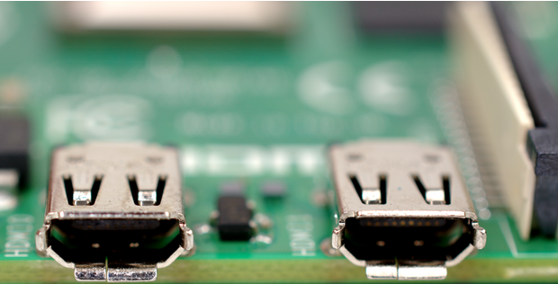The HDMI twin ports offer a high standard with 4K displays; this allows to screen at one time.

The pi also has a Gigabit Ethernet and USB 3.0 ports as seen below, this gives the pi 4 more speed and faster response time.

## Raspberry Pi emulator

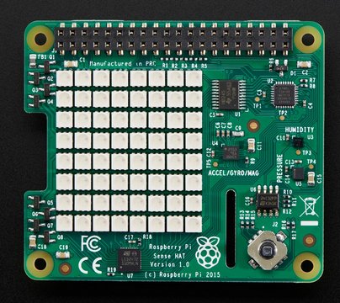

“*The Sense HAT was first developed for the*[***Astro Pi***](https://astro-pi.org/) *project and launched into space in December 2015, before becoming available for purchase. With the Sense HAT, you can create physical computing projects that use sensors and joystick inputs and show outputs on the LED matrix.*

*The Code Club Sense HAT projects are written for the Trinket Sense HAT emulator, so you don’t need a physical Sense HAT for them. But you can also complete the projects using a physical Sense HAT and a Raspberry Pi. If you only have Raspberry Pis, you could use the Sense HAT emulator that’s included on its operating system (you’ll find it in the Programming section of the menu). It works in the same way as the Trinket emulator*.”

Available @: club, c., 2021. *Sense HAT*. [online] The Raspberry Pi Foundation. Available at: <https://help.codeclub.org/en/support/solutions/articles/19000092564-sense-hat> [Accessed 7 November 2021].

## Raspberry Pi over the years

All models feature a Broadcom SoC consisting if ARM compatible CPU with on-chip GPU, the Video Core IV. CPU speed ranges from 700 MHz to 1.2 GHz for the Pi 3 and on-board memory range from 256 MB to 1 GB RAM. SD cards are used to store the OS the pi4 has 4 USB slots and an Ethernet port, there is also built in WI-FI 2.4 GHz and 5 GHz 802.11b/g/n/ac, the older ones.

The first generation of the board had 256 MB RAM, split equally between the CPU and the GPU. The next generation doubled the RAM whereas the third generation doubled it further. Raspberry Pi 3 Model B released in February 2016, consists of on-board Wi-Fi, Bluetooth, and USB boot capabilities. And the boards used the Broadcom BCM a 700MHz ARM1176JZF-S processor.

Raspbian has been the most popular among the operating systems due to the boost provided by the Raspberry Pi foundation. It is a Debian based Linux operating system easily available at the foundation website. Some of the popular operating systems are.

Here is a list of some of the more popular Operating Systems used on the pi.

|  |  |
| --- | --- |
| * Raspbian | * CentOS |
| * Fedora | * Ubuntu MATE |
| * Kali Linux | * Ubuntu Core |
| * Windows 10 IoT Core | * RISC OS |
| * Slackware | * Debian |
| * Arch Linux ARM | * Android Things |
| * SUSE | * FreeBSD |
| * NetBSD |  |

Below a full list of suitable operating systems:

|  |  |  |
| --- | --- | --- |
| * Alpine Linux | * Android Things | * Arch Linux ARM |
| * Ark OS | * CentOS | * ChameleonPi |
| * Diet Pi | * Fedora 25 | * FreeBSD |
| * Genode OS Framework | * Gentoo Linux | * Haiku, |
| * Happi Game Center | * HelenOS | * Inferno (in beta) |
| * Instant WebKiosk | * IPFire | * Kali Linux |
| * Kano OS | * Lakka | * LibreELEC |
| * Media Center OS | * Modeaudio | * Moebiius |
| * Nard SDK | * NetBSD | * Octopi |
| * OpenELEC | * OpenSUSE | * OpenWrt |
| * OSMC | * Pardus ARM | * Pidora |
| * Pimusicbox | * Piplay | * Puppy Linux |
| * Fedora Remix | * Rasplex | * Recalbox |
| * RedSleeve | * Retropie | * RISC OS |
| * ROKOS | * Runeaudio | * Sailfish OS |
| * Slackware ARM | * SolydXK | * Tingbot OS |
| * Tiny Core Linux | * Void Linux | * Windows 10 IoT Core |
| * WTware | * Xbian | * Xbian |
| * XV6 |  |  |

Here is a video on getting started with the pi

[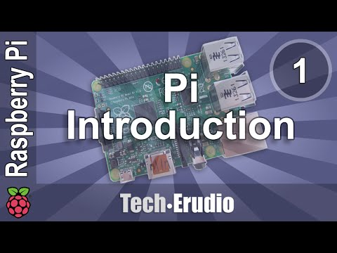](https://www.youtube.com/embed/Jj4pjfU_-jo?feature=oembed)

This is the [link](https://www.youtube.com/watch?v=Jj4pjfU_-jo) to the video,

and this is the hard copy link

https://www.youtube.com/watch?v=Jj4pjfU_-jo

# Flow chart

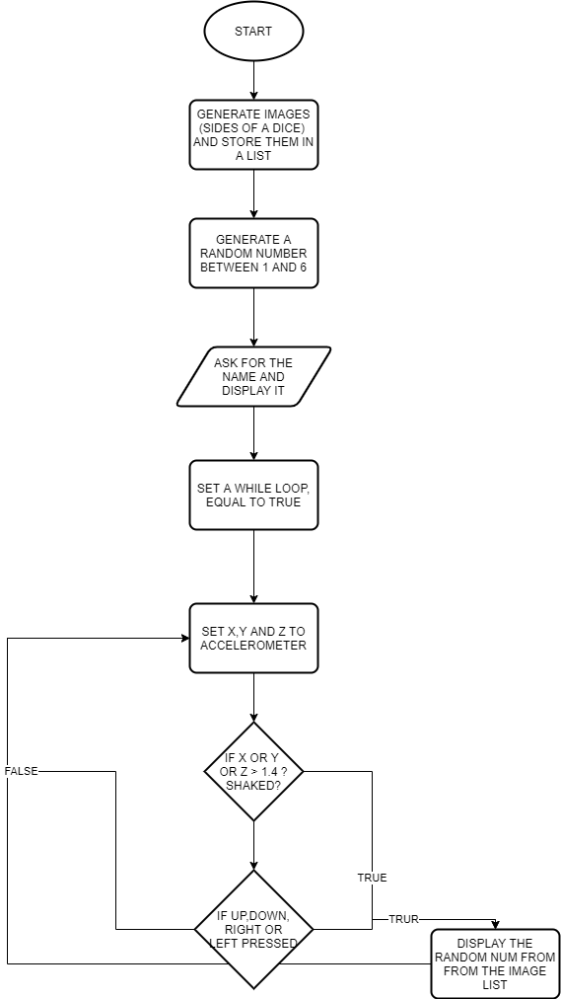

# Build: hardware/software

Imported Sense-Hat, Random, Time and Doc-test library, then set up lists for colours then store them in a different list (maintain)

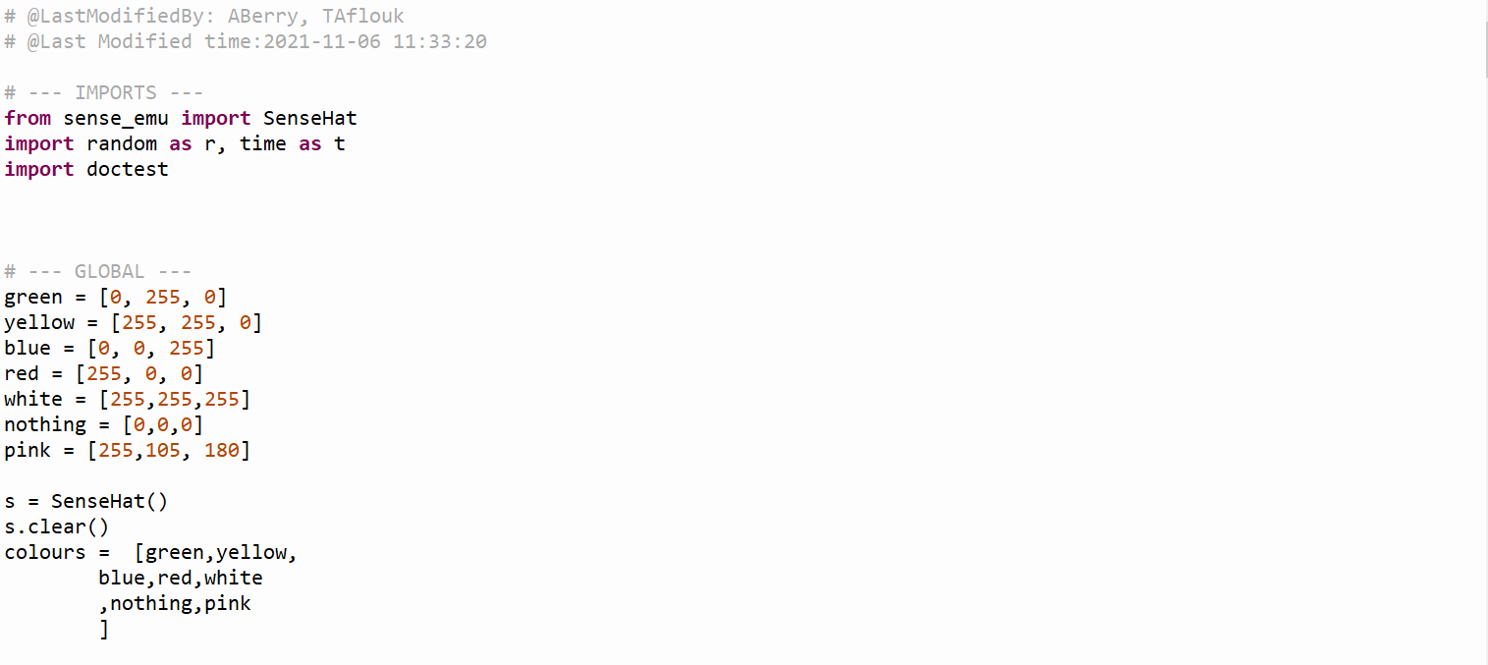

6 Sides Functions, to generate sides of a dice from random image of each side.

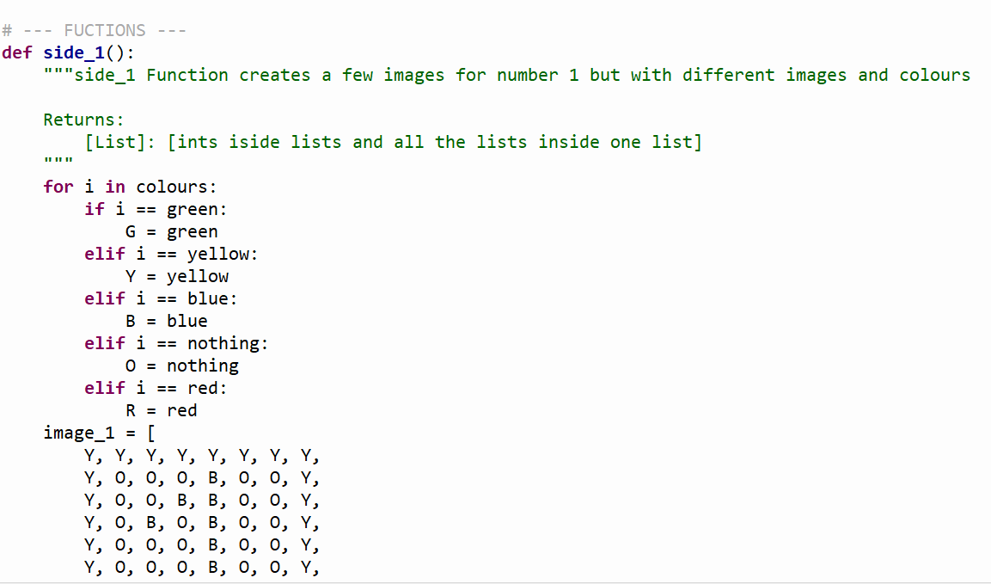

Roll dice Function, it is like a helper function to roll a random number between 0 – 6 depending on the list of sides.

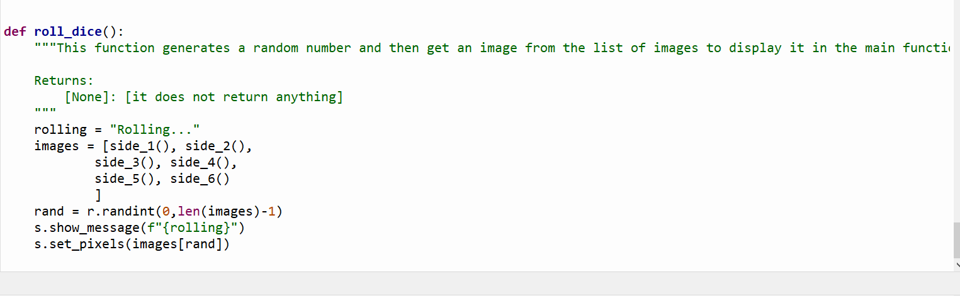

Main Function

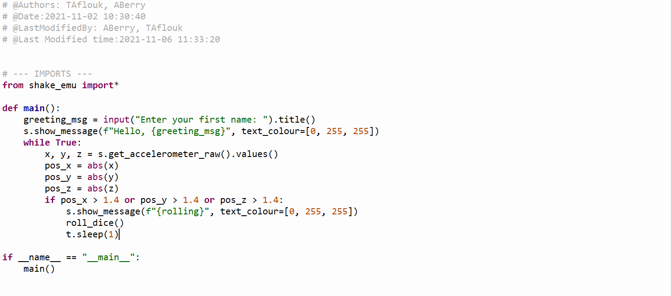

# Test: emulator/hardware

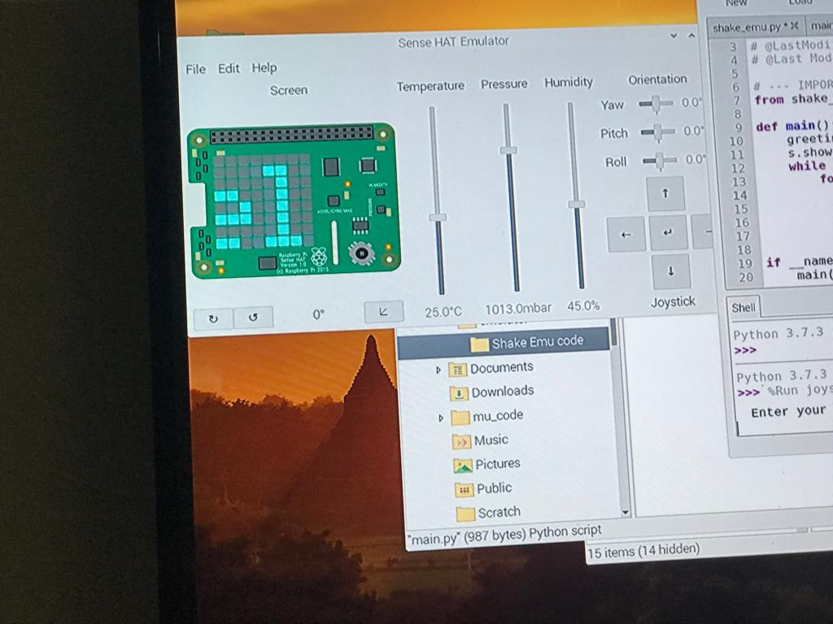

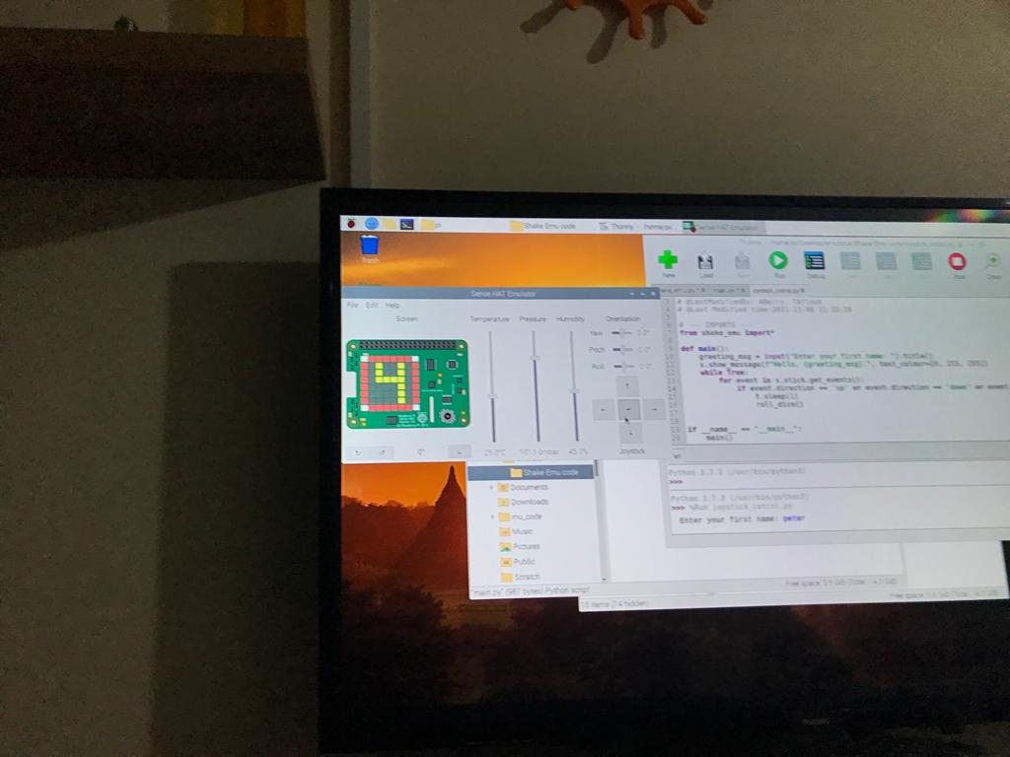

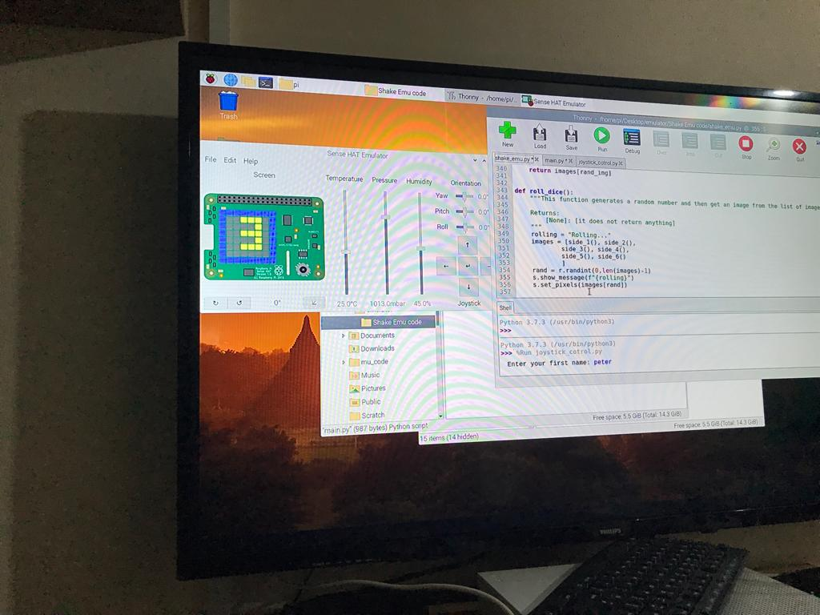

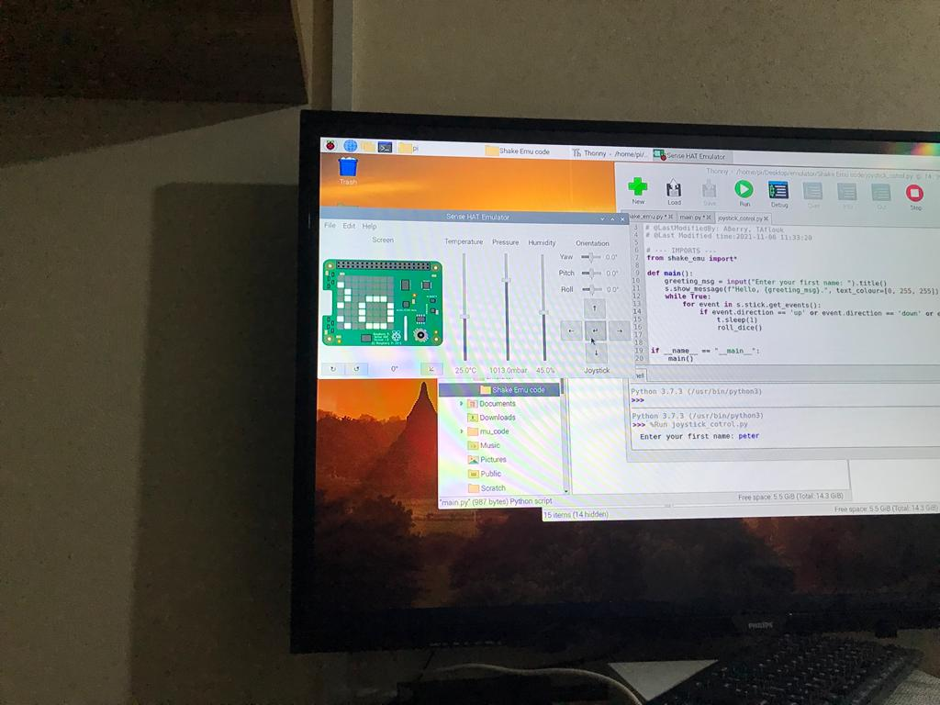

# Conclusion: individual section

## Alan:

For Its price you get better speed and has USB 3.0 X2 ports which can connect to two screens and give up to 4K resolution, they come with up to 8 Gigabytes which is fantastic for something so small, it can be used as a minicomputer so is also popular in industry too,

## Taha:

Pi is great tool but also, we need some knowledge to know how to use it, like we were controlling it with Python programming language, also it has some apps for kids and beginners like personally I enjoy doing them it is like a toolbox with self-teaching.

It was valuable experience to work at the start as a Team.